**The Hong Kong Polytechnic University Department of Computing**

COMP4913 Capstone Project

Interim Report

**Simulation and Analysis of Inter-satellite**

**Communication for Real-Time Data**

**Downloading**

Student Name: Tsang Chun Hei

Student ID: 21032048d

Programme-Stream Code: 61431 – COMP

Supervisor: Dr. LYU Mingsong

Submissiob Date: 2 Jan 2023

**Table of Content**

1. Introduction 3

1.1 Motivation 3

1.2 Background and Problem Statement 3

1.3 Aim and Objectives 5

2. Project Methodology 7

2.1 LEO satellite space geometry, Visibility, and Communication modeling 7

2.2 Decision-making algorithm for communication 7

2.3 Experiments and demonstration 7

3. Design 8

3.1 Orbit Modeling 8

3.2 Visibility Modeling for Observation 10

3.3 Visibility Modeling for Communication 11

3.3.1 Satellite to Ground Station Visibility 11

3.3.2 Satellite to Satellite Visibility 12

4. Implementation 14

4.1 Resources Estimation 14

4.1.1 Hardware Requirement Estimation 14

4.1.2 Software Requirement Estimation 14

4.1.3 Use of Library 14

4.2 Project Schedule 14

5. Conclusion 16

6. References/Bibliography 17

# Introduction

## Motivation

Nowadays, thousands of satellites are launched in the Low Earth Orbit (LEO). LEO satellites orbit below 2000 kilometers above the earth. It is expected that in the period from 2014 to 2023 an average of 115 small LEO satellites will be launched per year (Sebestyen et al., 2018). Which is used for communications, military reconnaissance, spying and other imaging applications. The LEO satellites made for communication benefit from the lower signal propagation delay in LEO. The environment in LEO provides lower propagation delay and able to communicate with Earth-based stations with utmost efficiency (Shustova, 2022), resulting in low-latency, high bandwidth, and universal internet connectivity (Vasisht et al., 2021). Meanwhile, LEO satellites are closer to the earth's surface, so imaging satellites will also be able to capture better and more detailed pictures (Shustova, 2022).

However, the communication range of LEO satellite exist a coverage issues, and there is a limited numbers of ground station. It results to an LEO satellite may fly for many hours to end up in the communication scope of a ground station and takes a long time for an LEO satellite to download the data to the ground.

## Background and Problem Statement

The communication coverage of Low Earth Orbit (LEO) satellites is much smaller than the higher altitude satellites. Ground stations can communicate with LEO satellites only when the satellite is in their visibility region and the duration of the visibility, and the communication vary for each LEO satellite passing over the station since LEO satellites move too fast over the Earth. (Cakaj et al., 2014). As a result, an LEO satellite may fly for many hours to end up in the communication scope of a ground station. Since the number of ground stations on the ground is limited, it takes a long time for an LEO satellite to download the data to the ground. The data satellite must wait at the satellite before it comes in contact with a ground station (Vasisht et al., 2021).

Therefore, inter-satellite communication is hard to meet the strong real-time constraints. A real-time system requires to guarantee events can be completed in a set amount of time. However, cause of the feature of LEO satellites and the distribution is not fixed, it is hard to complete the data transmission in a set amount of time when the path of data transmission is not ensured.

Inter-satellite communication offers a new opportunity to achieve real-time data downloading, even if the number of ground stations is limited. Suppose an LEO satellite has some data to download and cannot find a ground station within a specified deadline. In that case, the satellite can transfer the data to another satellite that can communicate to some ground station. Therefore, the data downloading may probably meet the specified deadline.

In this project, we study the problem of meeting real-time data downloading requirements with inter-satellite communication. When a satellite has data to download, it can either communicate to a ground station (if the satellite is in the communication scope of the ground station) or transfer the data first to another satellite that can communicate to some ground station. We will simulate the communication between an LEO satellite and a ground station and multiple satellites, specifically the communication capability and its delay. As an LEO satellite may have multiple choices in the downloading data path, we will explore if there is at least one path that can meet the download deadline, based on the simulation.

## Aim and Objectives

The overall objective is to analyze if the data download deadline can be met given the data on an LEO satellite can be transferred either directly to a ground station or via some other LEO satellite, given a configuration of an LEO satellite constellation and a set of ground stations. The analysis is conducted based on the simulation of the communication behavior between LEO satellites and between an LEO satellite and the ground stations.

There are several sub-tasks to achieve the above objective:

1. Simulation: to simulate the communication behavior
   1. To simulate the position of each satellite in space at a given time, based on which we can evaluate whether two satellites can communicate.
   2. To simulate whether a satellite is in the communication scope of a given ground station, given the related parameters.
   3. To simulate the data transfer latency, either between satellites or between a satellite and a ground station.
2. Optimization

There can be multiple paths for a satellite to download the data to the ground. Based on the simulation capability, an optimization algorithm will be developed to find the shortest communication path and check if the communication along this path can meet the data download deadline.

The simulator simulates the communication between Low Earth Orbit (LEO) satellites and the ground station, including the communications between LEO satellites. It aims to compute the real-time capabilities of a group of LEO satellites in data downloading by simulating the environment of LEO and referring the existing satellites to obtain data close to reality. Meanwhile, the simulator simulates the LEO environment with space geometry and satellite communication.

The simulator will simulate the real LEO environment by using the real LEO environment feature and the space geometry when calculating the satellite orbit. The LEO satellite visibility modelling and decisions of data transmission will use the existing satellite data to guarantee the result is close to reality.

The outcome of the project will be a simulator to show all the orbits, data transmission path, and transmission delay. The final outcome will allow users to customize the orbit and satellites including the orbit used in the simulation, find out the path of data transmission and show the delay of the transmission.

# Project Methodology

## LEO satellite space geometry, Visibility, and Communication modeling

In the space geometry modeling, there are mostly using the mathematical algorithm in space geometry. These algorithms will be development with python and using the “NumPy” library to assistance. Algorithms used in this section:

* Earth Rotation, Gravity Computation
* Satellite Off Nadir Angle Computation
* Right Ascension Computation
* Satellite observation Latitude range Computation
* Satellite to Ground Station Communication Delay Computation
* Inter-Satellite Communication Delay Computation
* And more

## Decision-making algorithm for communication

In this section, algorithms may use to compute the distance between satellite and making decision of select the next satellite need to transmit the data. It may use algorithms or machine learning method, depends on the ability and efficiency of making the decision.

## Experiments and demonstration

To demonstrate the work of this project, we will use the simulator to output the dynamics of the satellites and the potential communication paths for data downloading, and we will also show the shortest path that is found by the decision-making algorithm.

# Design

## Orbit Modeling

To local the ground target and Satellite in space, the Earth-Centered Inertial (ECI) is used as the coordinate system. ECI coordinate system is a 3-dimensional Cartesian coordinate system with the original fixed center in the Earth's mass center, which remains fixed with respect to Earth's surface in its rotation and rotates with respect to stars.

Except for using the (x, y, z) to represent the point in the coordinate system, right ascension (denoted by α) and declination (denoted by δ) are used to represent the angular position of the point. The right ascension of point P in Fig. 1 is the angular distance of point P which is measured eastward along the celestial equator from the x-axis of an ECI coordinate to point P. The declination is the angular distance from the equatorial plane to point P in Fig. 1 which is measured along the hour circle passing through point P.

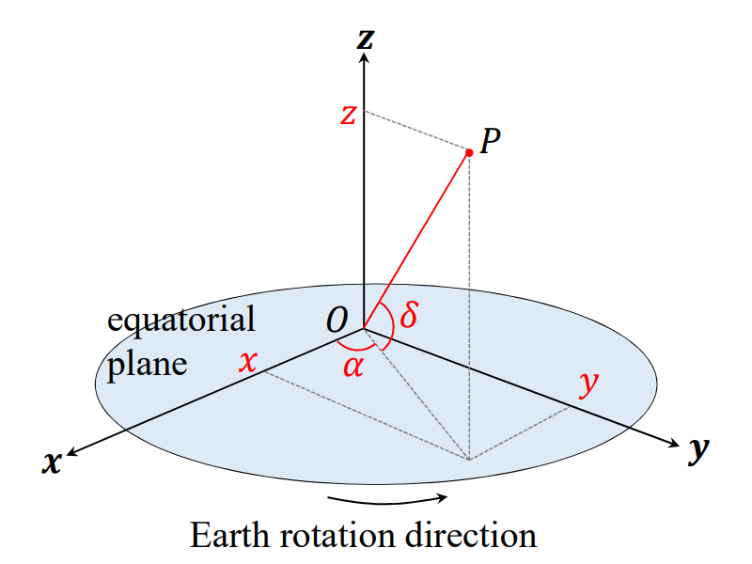

Fig. 1 Elements of ECI coordinate system

Fig. 1 shows the ECI coordinate and the position parameters of point P. r in Fig. 1 is the distance from point P to the original point in the ECI coordinate system. The (x, y, z) value in the coordinate system can be computed by the equations below.

$$x=r*\cos{δ}*\cos{α}$$

$$y=r*\cos{δ}*\sin{α}$$

$$z=r*\cos{δ}$$

Earth is an ellipsoid very close to a perfect sphere. But for simplicity of the calculation, the Earth is assumed as a perfect sphere. The self-rotation of the Earth is eastward along the celestial equator with an angular speed of 2π per day. Because of the self-rotation of the Earth, the (x, y, z) value in the coordinate system and the right ascension of the point following the self-rotation and satellite movement continue to change in the ECI coordinate. But the latitude of the point, coinciding with its declination, remains unchanged.

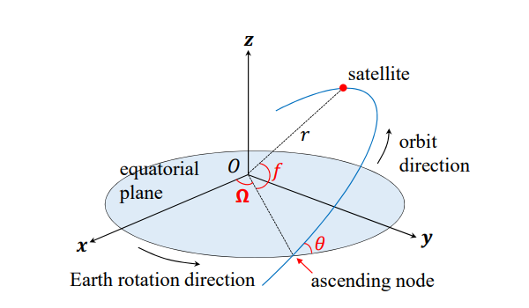

Fig. 2 Elements of Satellite Orbit

In Fig. 2, point P has a longitude (λ) and a latitude (φ). At time $t_{0}$, P has a right ascension of $α_{0}$ and a declination of $δ_{0}$. After a time passed, a new right ascension $α_{t}$, new declination $δ_{t}$ cam be computed by the following equations. Where $ω_{e}$ denotes the angular speed of self-rotation of the Earth ( $ω_{e}$ = 2π/day).

$$αt = (α_{0} + t · ω_{e}) mod 2π; δt = δ0$$

Because of the altitude of LEO satellite is low which take the orbit is close to the perfect circle. Therefore, in this project, satellite orbit is assumed as a circular orbit. There are orbit information shown in Fig. 2 used to describe a satellite as below.

* R: the radius of the orbit
* θ: the inclination angle from the equatorial plane to the orbit plane which measured above the equatorial plane when θ in $\left[0, \frac{π}{2}\right]$, the orbit is same direction as the Earth rotation. when θ in $\left[ \frac{π}{2},π\right]$, the orbit is opposite direction as the Earth rotation
* Ω: the right ascension of the ascending node which is the point where the orbit crosses the equatorial plane northward.
* F: the true anomaly which is the angular difference from the equatorial plane to the initial position of the satellite.

## Visibility Modeling for Observation

To model the characteristics of the visibility scope of the satellite for the observation target, the visibility scope is determined by the altitude of the satellite and the capability of the satellite camera. As Fig. 4, S is the satellite, P is the observation target, and O is the center of Earth. There is a sub-satellite point B which is a point on Earth's surface intersecting with the line O to S. γ is the plane that is tangent to the Earth at P.

The camera of the satellite is mounted on a head and initially points to the sub-satellite point. At the run time, the camera can swing for an off-nadir angle (β in the Fig. 3) to take an image. The off-nadir angle is limited, so the visibility scope of an LEO satellite is limited by the maximum off-nadir angle. If the satellite is right above the observation point P, the off-nadir angle will be 0.

The current β can be computed with the observation target and the satellite. If the current is smaller than the maximum β and the satellite is above the γ plane, then the satellite can capture the image of the observation target.

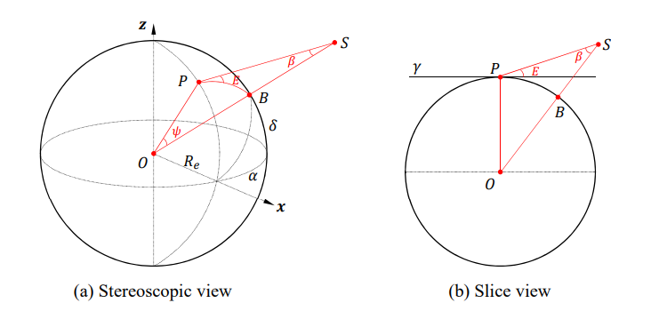

Fig. 3 Observation Visibility

Because the position of the observation target and satellite is continuously changed by the Earth's rotation and satellite movement. For future development of communication, the visibility model can compute the time window of the satellite's ability to visit the observation target by comparing the β at any time with the maximum β.

## Visibility Modeling for Communication

### Satellite to Ground Station Visibility

To communicate with the ground station, the satellite must be within the communication scope of the ground station. The visibility model is used to find out if the ground station is visitable by a satellite. The main determining factor of the modelling is the elevation of the ground station (as shown by angle E in Fig. 4) which is the angle to measure the perpendicular to the earth’s surface. if the elevation angle of the ground station is 90 degrees, it means the satellite is right above the ground station. The elevation angle can be changed by the Earth's rotation and satellite movement. When the elevation angle is too small, the satellite will not able to communicate with the ground station.

Because the visibility model of communication is similar to the visibility model of observation, the visibility model of observation can be reused to compute the communication scope. P in Fig. 4 can seem like the ground station. According to the principles of triangles, there is a fixed relationship between the angle β and elevation E, so

$$R_{Earth}*\cos{E}=r*\sin{β}$$

The minimal elevation is typically specified by the ground station. In the range [0◦, 90◦] when E increases, β decreases. So, the maximal β can be computed by the above equation. When current β is smaller than the maximal β, the satellite is within the communication scope. And able to compute the time window of the satellite's ability to visit the ground station by comparing the β at any time with the maximum β.

### Satellite to Satellite Visibility

If the satellite is not within the communication scope of the ground station, the data can be transferred to another satellite. For this purpose, a visibility model is needed to find out the satellite communication scope. The visibility model in satellite-to-satellite visibility is difference with the satellite to ground station visibility modeling.

Because the distance of satellite-to-satellite communication range is typically unlimited in LEO, so the main determining factor of the model is the communication of two satellites whether being blocked by the Earth. Because the distance of satellite-to-satellite communication range is typically unlimited in LEO, so the main determining factor of the model is the communication of two satellites whether being blocked by the Earth. The maximum off-nadir angle (β in the Fig. 5) can be computed by the following equation when S2 is the satellite contain the data.

$$β_{max}= \sin^{-1}{(R_{Earth}/r_{2})}$$

The current $β$ can be computed by the bisector (shown as h in Fig. 5) of $r_{1}$ and $r_{2}$. When $β$ is bigger than $β_{max}$, both satellites can communicate to each other.

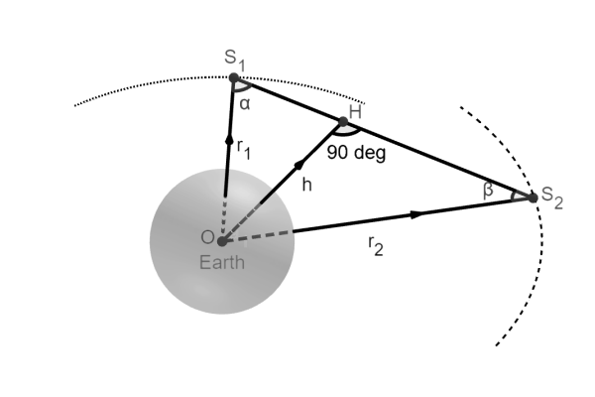

Fig. 5 Satellite to Satellite Visibility

# Implementation

## Resources Estimation

### Hardware Requirement Estimation

* Computer able to run .py file

### Software Requirement Estimation

* Python 3.8
* Pip (for install library)
* Code Editor/ File Editor ()

### Use of Library

* numpy (For calculation)
* xlwt (For output data to excel file)
* Datetime

## Project Schedule

|  |  |
| --- | --- |
| **Subject** | **Deadline** |
| LEO satellite space geometry modeling   * Multi orbit calculation * Space Geometry Modeling | 1 Nov 2022 |
| Visibility Modeling   * Define the detection range of satellite * Successfully the observation target within the detection range | 1 Jan 2022 |
| Communication Modeling   * Download an image from satellite to satellite * Download an image from satellite to ground station | 1 Feb 2023 |
| Decision-making algorithm for communication   * Successfully making path decision of communication | 1 Mar 2023 |
| Experiments and demonstration   * Complete a set of experiments to show the simulation results and the decision-making results | 1 Apr 2023 |

# Conclusion

To conclude, the project is to analyze the problem of inter-satellite communication systems to meet the constraints of real-time systems by simulation. The current inter-satellite system could not guarantee the data transmission can be completed in a set amount of time. To analyze the problem of inter-satellite communication systems, this project simulates the communication between an LEO satellite and a ground station and multiple satellites, specifically the communication capability and its delay. And try to met the deadline of the data download from LEO satellite.

# References/Bibliography

Shustova, A. (2022, April 19). *What are some applications of a leo satellite?* Dragonfly Aerospace. Retrieved October 12, 2022, from https://dragonflyaerospace.com/what-aresome-applications-of-a-leo-satellite/

Cakaj, S., Kamo, B., Lala, A., & Rakipi, A. (2014). The coverage analysis for low Earth orbiting satellites at Low Elevation. *International Journal of Advanced Computer Science and Applications*, *5*(6). https://doi.org/10.14569/ijacsa.2014.050602

Mingsong Lv, Xuemei Peng, Wenjing Xie, Nan Guan. (2022). Task Allocation for Real-time Earth Observation Service with LEO Satellites. Accepted to 43rd IEEE Real-Time Systems Symposium (RTSS 2022).

Sebestyen, G., Fujikawa, S., Galassi, N., & Chuchra, A. (2018). *Low Earth Orbit Satellite Design*. Springer Publishing.

Vasisht, D., Shenoy, J., & Chandra, R. (2021). L2D2. *Proceedings of the 2021 ACM SIGCOMM 2021 Conference*. https://doi.org/10.1145/3452296.3472932

Cinelli, M., Ortore, E., Laneve, G., & Circi, C. (2021). Geometrical approach for an optimal inter-satellite visibility. *Astrodynamics*, *5*(3), 237–248. https://doi.org/10.1007/s42064-020-0099-0